whoami [current working user]

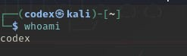

hostname [current host]



pwd [current working directory]

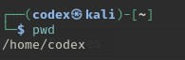

ls [listing directory & files]



cd [change directory]

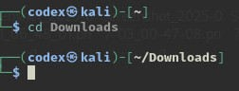

man ls [manual for command]



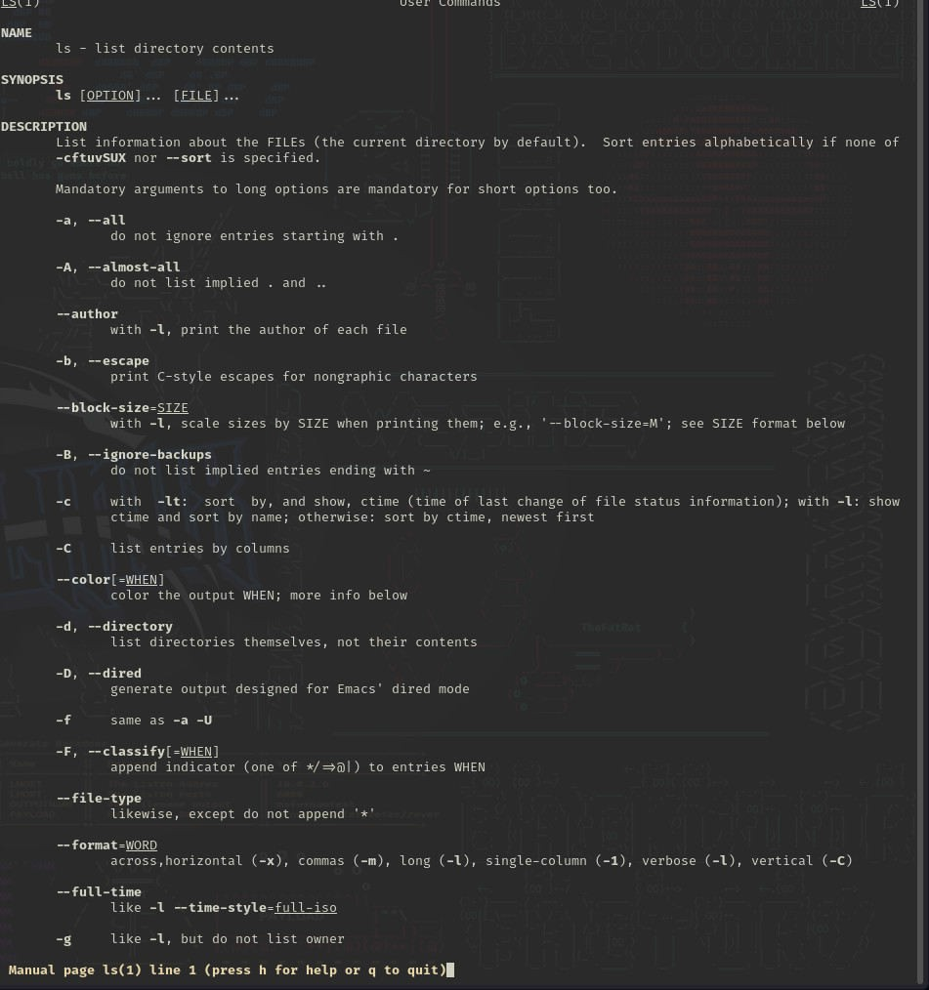

info ls [information for command]

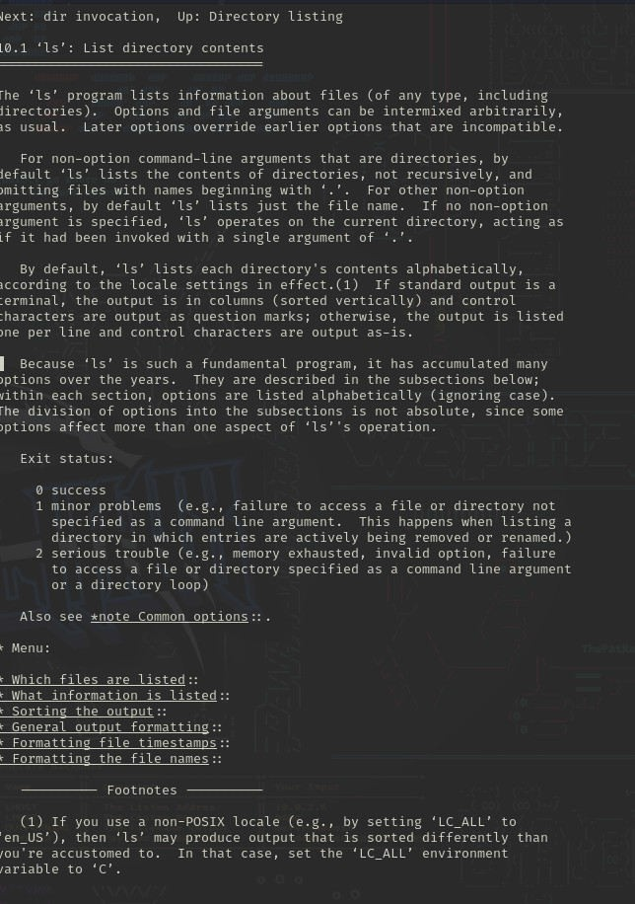

ls --help [specific options usage for command]

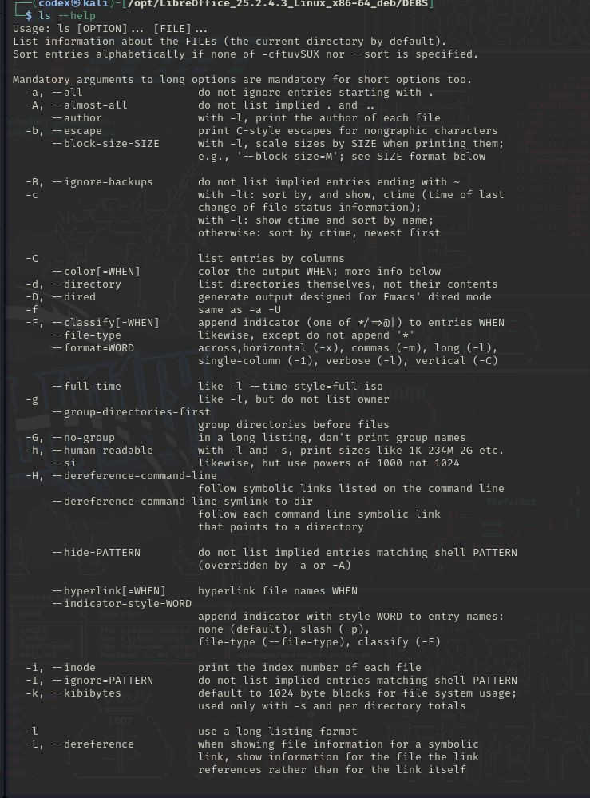

explainshell.com [for understanding complex command] ls -la [all files and directories]

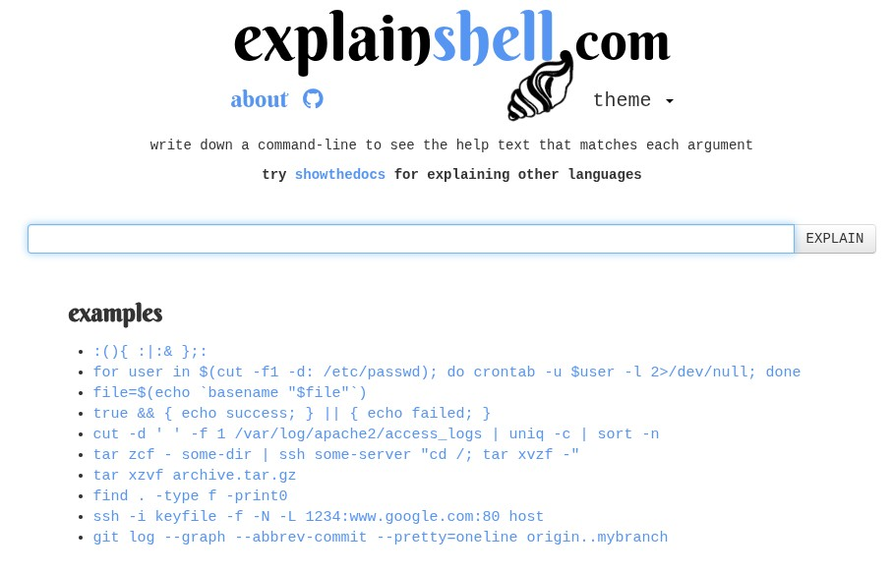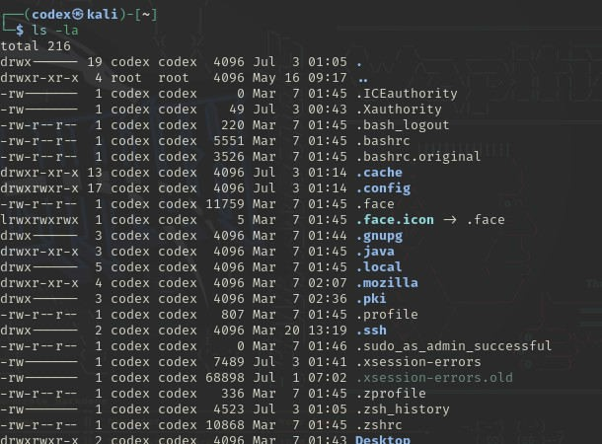

more d4l.txt [to see the content and you can look forward]

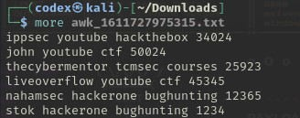

less d4l.txt [to see the content but you can not look back ]

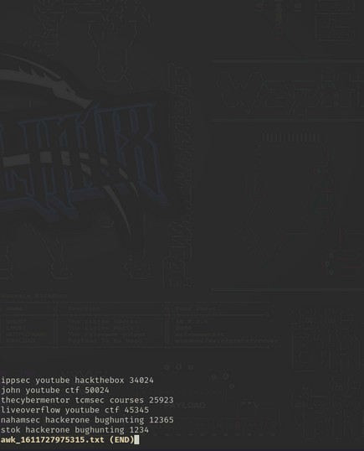

cat file.txt [for opening a file]

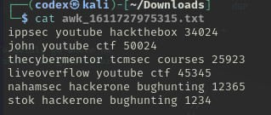

cat -b d4l.txt [for opening and count through numbering ]

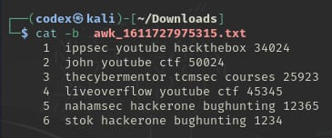

du -sh ~ [displays disk usage by the directory]

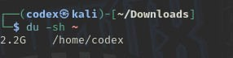

ls -l d4l.txt [shows the last time of modification by any user]

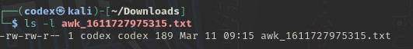

touch d4l.txt [updating time of the last modification]



touch test.txt [for creating a new file]



cp file1 file2 [copying the file]

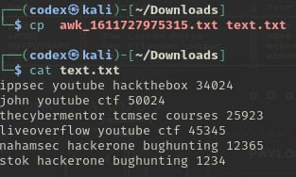

mv file1 /root/file2 [for moving file]



rm file1 [for deleting a file]

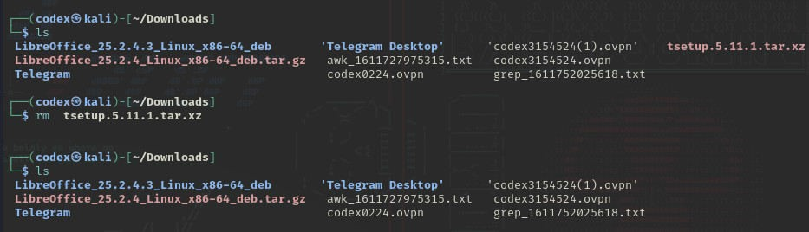

mkdir project [creating directory]



rmdir project [for deleting empty directory]l



ls "file name.txt" [to see spaced file named file]



head wordlist.txt [showing first of a file]

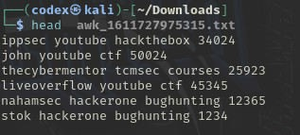

head -n 5 word.txt [showing the first 5 content]

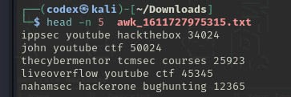

tail -n 5 word.txt [showing the last 5 content]

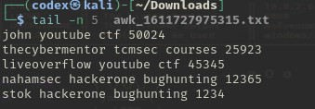

diff file1.txt file2.txt [comparing the differences of two files]

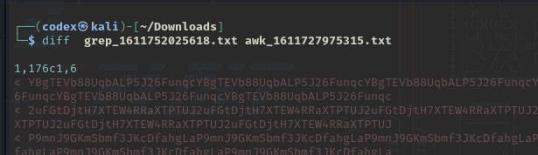

which ls [finding which command is being executed]

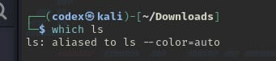

users [for checking which user it is]

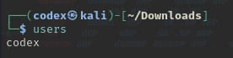

passwd [for changing password]

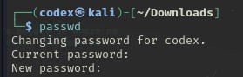

sudo apt update [for updating linux] sudo apt upgrade [for upgrading linux]

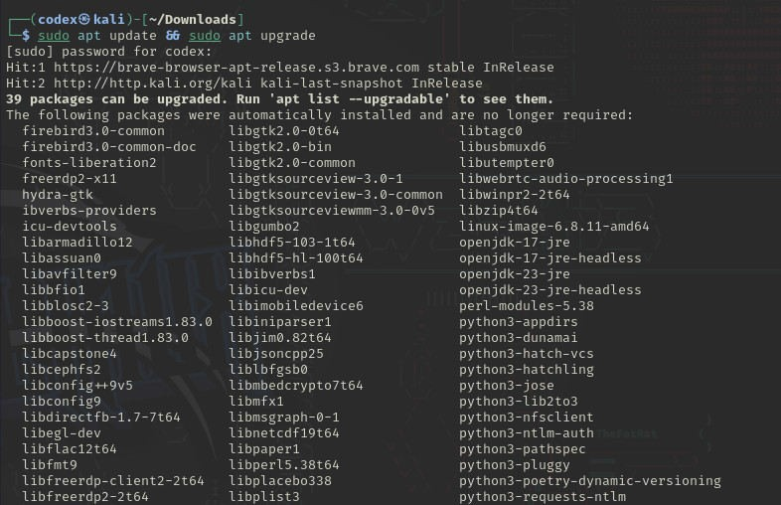

which pdftk [for checking any software is installed in system or not]

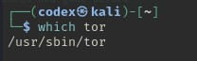

apt search pdftk [searching for a software]

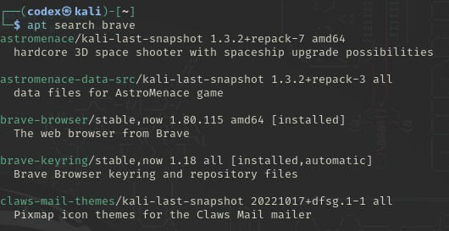

apt show pdftk [info about pdftk software]

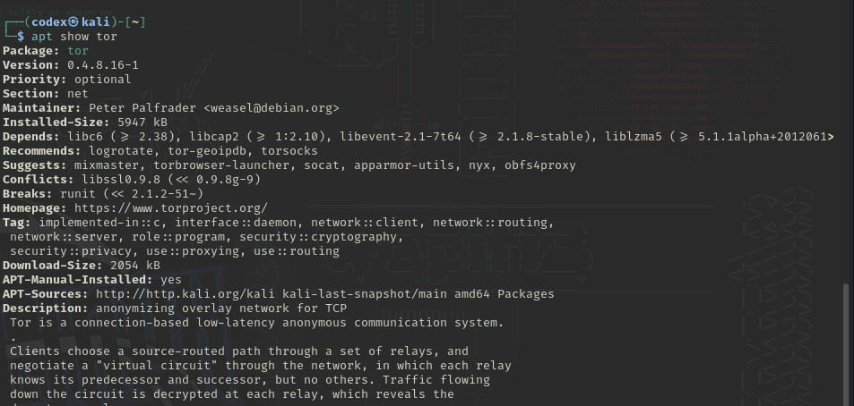

apt install pdftk-java [installing software]

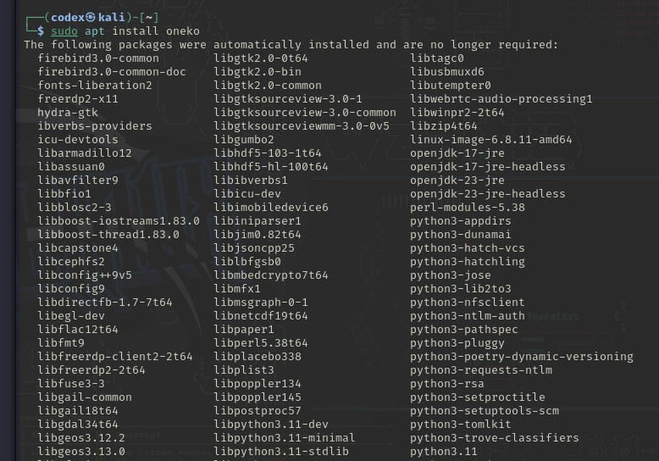

apt remove pdftk-java [for removing a software]

wget https://abc.com/2.3.4.tar.gz [downloading file]

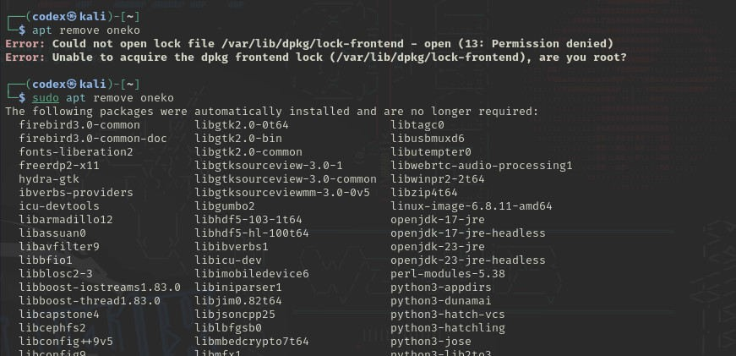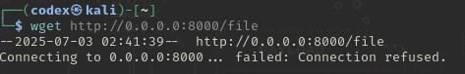

tar xfz 2.3.4.tar.gz [extracting tarball]



git --version [checking which version of git it is]



ls -al [file listing]

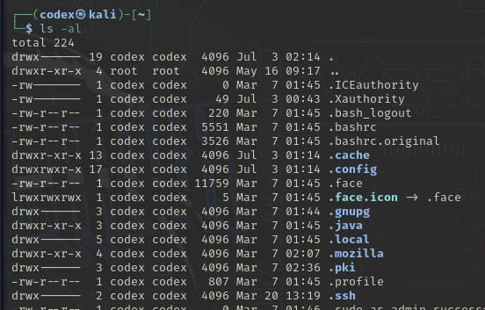

nano file.txt [text editor]

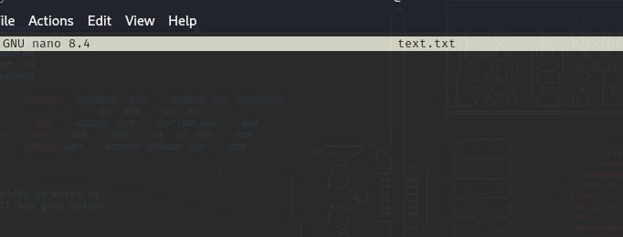

ping google.com

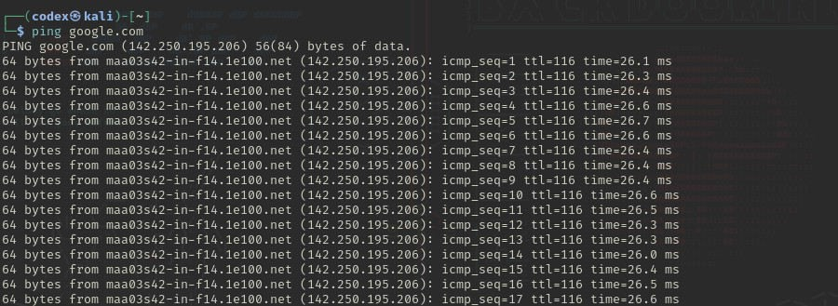

ifconfig

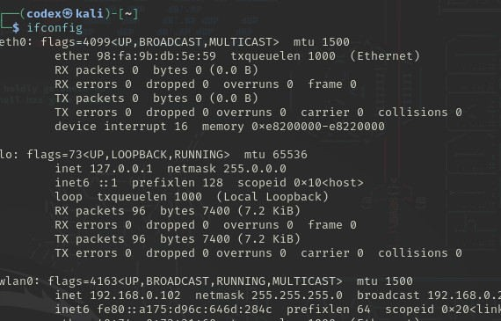

iproute

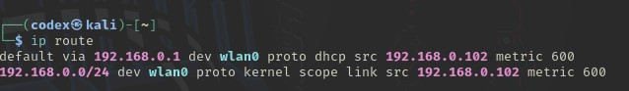

sudo su [for acquiring root privileges]

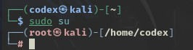

locate testagain.txt [for finding files]

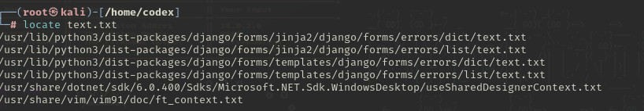

whois (web or ip address)

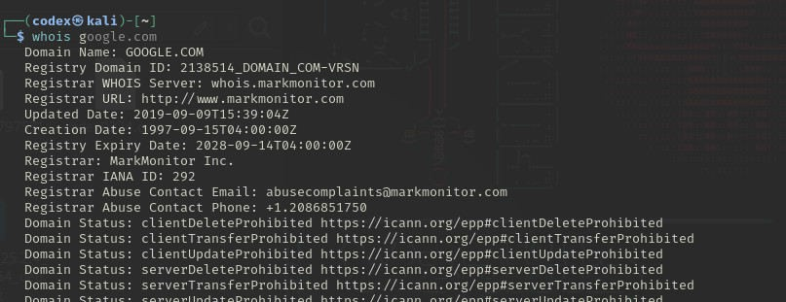

TheHarvester

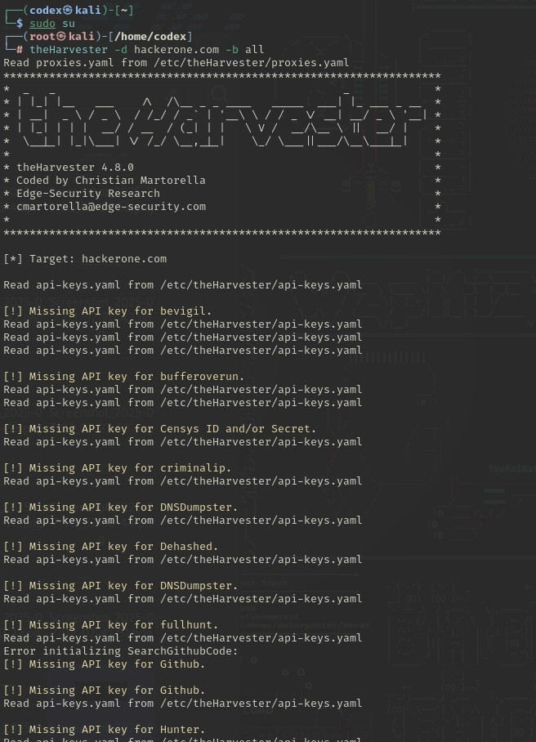

Sherlock

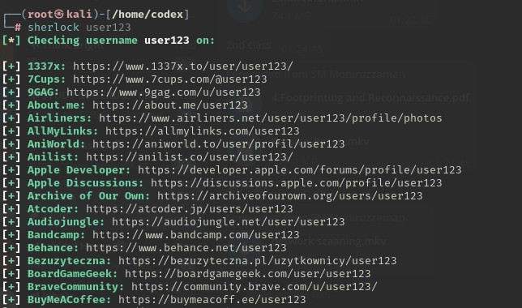

Crosslinked

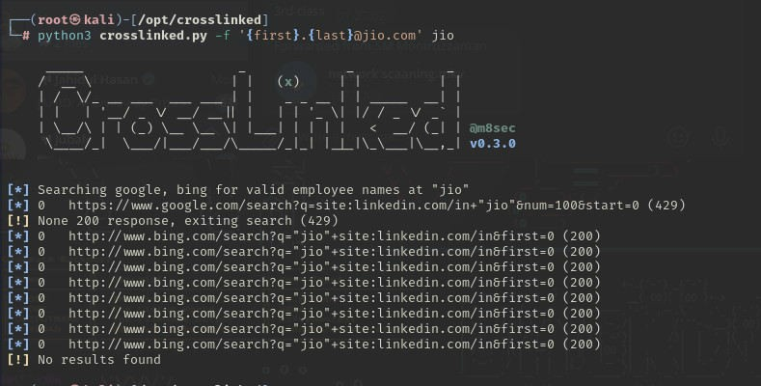

Recon-ng

